FX545P

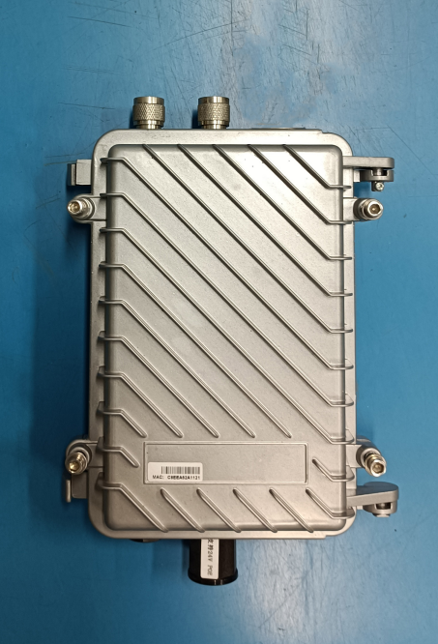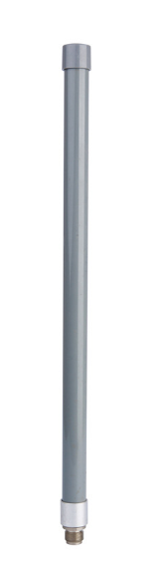

参数规格
硬体规格
特性 | 说明
CPU | AR9531
DDR | 64/128M
闪存 | 8/16M
PoE电源 | 支持标准POE 48V电源
CPU主频 | 650 MHz
天线配置 | 2×2 (2Tx,2 Rx)
有线接口 | 1个有线口
以太网物理速率 | 10/100Mbps
重置按钮 | 使设备恢复出厂设置
电源要求 | POE 24/48V
调制方式 | OFDM/BPSK/QPSK/CCK/DQPSK/DBPSK
射频频率范围 | China : 2412 GHz ~ 2484 GHz (信道1 ~ 信道13)
输出功率 @25℃  (±1.5dB) | 802.11b | 27.0 ± 2dBm
 | 802.11g | 6-9Mbps |  |  | 26.0± 2dBm
 |  | 12-18Mbps |  |  | 25.5± 2dBm
 |  | 24-36Mbps |  |  | 25.0± 2dBm
 |  | 48-54Mbps |  |  | 24.5± 1.5dBm
 | 802.11n | HT20 | MCS 0-3 |  | 25.5 ± 2dBm
 |  |  | MCS 7 |  | 24.0± 1.5dBm
 |  | HT40 | MCS 0-3 |  | 25.5 ± 2dBm
 |  |  | MCS 7 |  | 24.0 ± 1.5dBm
灵敏度 | IEEE 802.11b  1Mbps≦-91dBm  11Mbps≦-87dBm | IEEE 802.11g  6Mbps≦-89dBm  54Mbps≦-72dBm |  | IEEE 802.11n  HT 20  MCS 0≦-85dBm  MCS 7≦-67dBm  HT 40  MCS 0≦-82dBm  MCS 7≦-64dBm
环境规格
特性 | 说明
工作湿度 | 0%~90%非凝结
操作温度 | -20~+60°C
存放温度 | -40~+80°C

